# Blog: JavaScript and MongoDB

This document defines a complete walkthrough of creating a **Blog** application with the [Express.js](http://expressjs.com/) Framework, from setting up the framework through [authentication](http://passportjs.org/) module, ending up with creating a **CRUD** around [MongoDB](https://www.mongodb.com/) entities using [Mongoose](http://mongoosejs.com/) object-document model module.

Make sure you have already gone through the [Getting Started: JavaScript](https://softuni.bg/downloads/svn/soft-tech/May-2017/Software-Technologies-July-2017/08.%20Software-Technologies-JavaScript-Blog-Basic-Functionality/08.%20Software-Technologies-JS-Blog-Getting-Started-Lab.docx) guide. In this guide we will be using: [WebStorm](https://www.jetbrains.com/webstorm/) and [RoboMongo](https://robomongo.org/) GUI. The rest of the needed non-optional software is described in the guide above.

**Chapters from I to III are for advanced users, but is recommended to be read. There’s a** [**skeleton**](https://softuni.bg/downloads/svn/soft-tech/May-2017/Software-Technologies-July-2017/08.%20Software-Technologies-JavaScript-Blog-Basic-Functionality/08.%20Software-Technologies-JavaScript-Blog-Basic-Functionality-Skeleton.zip) **which you can use and start from chapter IV.**

# Set Up Node.js Express Project

**WebStorm** comes directly with project structure plus we don’t need to download any plugins in order to develop our Node.js/Express.js application

## Create the Project from your IDE

Once you have installed the plugins and started the **IDE**, you will have in the **Create Project** context menu either a “Node.js and NPM**”** -> “Node.js Express app” (**IntelliJ** with **Node.js plugin**) or directly a “**Node.js Express app”** one (**WebStorm**)

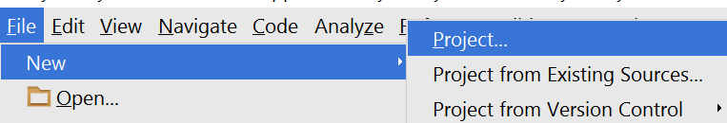

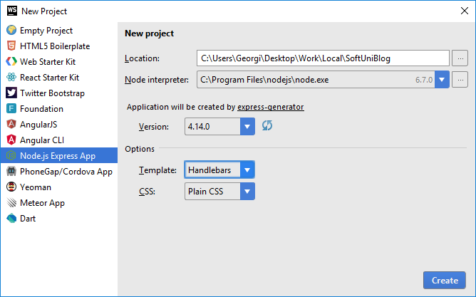

Make sure that you have [Node interpreter](https://nodejs.org/en/) installed and the chosen directory is the right one.

* + - * Also, choose the [Handlebars](http://handlebarsjs.com/) **Template**.
      * The recommended Express **versions** are any above **4.0.0**

## Create a Database

It’s time to create the database, which your app will use. We have two possible approaches here. Choose whichever one you prefer:

### Using the GUI

Open **RoboMongo**, connect to the default instance (with port: **27017**) and create a database named “blog”.

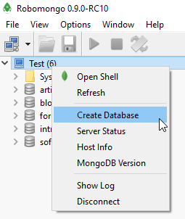

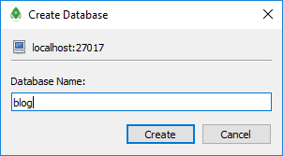

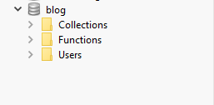

### Using the Command Line

Or if you want to do it using the **command line** use the following commands:

|  |
| --- |
| mongo  use blog  db.users.insert({"email": "test@gmail.com"})  db.users.find({}) |

**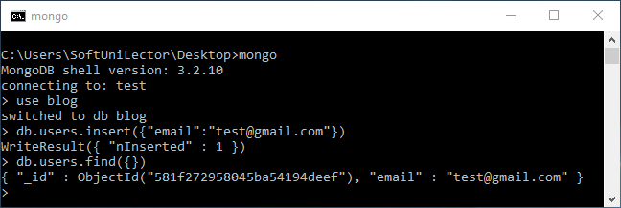**

**Note** that in order to use command line you should have all **environment variables** set or if not, you should run the command line from the place where **mongod.exe** is (“[C:\Program](file:///C:/Program) Files\MongoDB\Server\3.0\bin” - the version after server **might** be different – instead of 3.0 to 3.2, but the path is relatively the same). Also you should your **MongoDB** connection **open** (“**mongod –dbpath D:\example\path**” command).

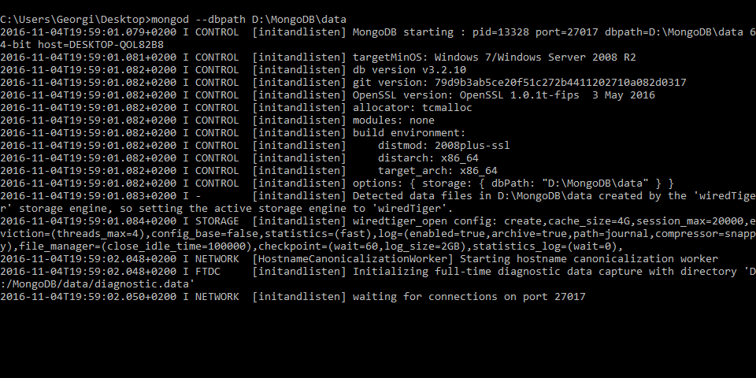

Once you set up your database, it’s time to get to work on the layout.

## Setup Layout

We will need a base layout for all of our templates. As we are using **Bootstrap**, we will need its css included in all pages, and the related scripts too. We can download the sample **blog design skeleton** from [here](https://softuni.bg/downloads/svn/soft-tech/Sep-2016/Software-Technologies-Oct-2016/03.%20PHP-Blog-Basic-Functionality/blog%20design.zip), where part of our **JavaScript** and **CSS** is included. In addition, we will need

* [Bootstrap Date Time picker](http://www.malot.fr/bootstrap-datetimepicker/) for choosing dates in our forms
* [Moment JS](http://momentjs.com/) for validating dates

All of our styles and scripts we need to include to our project. We should add stylesheets into the **public/stylesheets** and our public scripts in **public/JavaScript**. We will add the above two libraries when we need them:

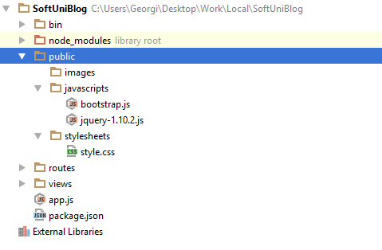

Then we need to use this styles and script setting up a base layout in views/layout.hbs.

Setup a base layout as you wish or use the following one:

|  |
| --- |
| <!DOCTYPE **html**>  <**html**>  <**head**>  <**title**>SoftUni Blog</**title**>  <**link rel='stylesheet' href='/stylesheets/style.css'** />  <**script src="/JavaScripts/jquery-1.10.2.js"**></**script**>  <**script src="/JavaScripts/bootstrap.js"**></**script**>  </**head**>  <**body**>  <**header**>  <**div class="navbar navbar-default navbar-fixed-top text-uppercase"**>  <**div class="container"**>  <**div class="navbar-header"**>  <**a href="/" class="navbar-brand"**>SoftUni Blog</**a**>  <**button type="button" class="navbar-toggle" data-toggle="collapse" data-target=".navbar-collapse"**>  <**span class="icon-bar"**></**span**>  <**span class="icon-bar"**></**span**>  <**span class="icon-bar"**></**span**>  </**button**>  </**div**>  {{#**if user**}}  <**div class="navbar-collapse collapse"**>  <**ul class="nav navbar-nav navbar-right"**>  <**li**><**a href="/user/details"**>Welcome({{**user**.**email**}})</**a**></**li**>  <**li**><**a href="/article/create"**>New Article</**a**></**li**>  **<li>**<**a href="/user/logout"**>Logout</**a**></**li**>  </**ul**>  </**div**>  {{/**if**}}  {{#**unless user**}}  <**div class="navbar-collapse collapse"**>  <**ul class="nav navbar-nav navbar-right"**>  <**li**><**a href="/user/register"**>Register</**a**></**li**>  <**li**><**a href="/user/login"**>Login</**a**></**li**>  </**ul**>  </**div**>  {{/**unless**}}  </**div**>  </**div**>  </**header**>  {{{**body**}}}  </**body**>  <**footer**>  <**div class="container modal-footer"**>  <**p**>**&copy;** 2016 - Software University Foundation</**p**>  </**div**>  </**footer**>  </**html**> |

# Node.js Express App Base Project Overview

Node.js is a **platform** written in **JavaScript** and provides **back-end** functionality. Express is a **module** (for now we can associate module as a **class** which provides some functionality) which wraps Node.js in way that makes coding faster and easier and it is suitable for **MVC** architecture.

Initially the project comes with the following structure:

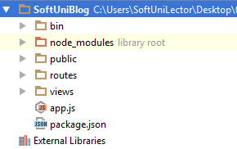

We can see several folders here. Let look at them one by one and see what are they for:

* **bin –** contains single file named **www**, which is the starting point of our program. The file itself contains some configuration logic needed in order to run the server **locally**.
* **node\_modules** (library root) – as far as the name tells in this folder we put every library (**module**) that our project depends on.
* **public** – here comes the interesting part. Everything that is in our public folder (files, images etc.) will be accessible by every user. We cover on that later.
* **routes –** folder in which we will put our routes configurations. To make things clear: routes are responsible for distributing the work in our project (e.g. when user tries to get on "[www.oursite.com/user/login](http://www.oursite.com/user/login)" to call the specific controller or module that is responsible for displaying login information)
* **views –** like in the previous blog (PHP) we again have folder named **views**. There we will store the views for our model. Again, we will use templates with the help of the **Handlebars** view engine.
* **app.js** – the script containing our server logic.
* **package.json** – file containing project information (like project's **name**, **license** etc.). The most important thing is that there is a "**dependencies**" part in which are all names and versions of every module that our projects uses.

# User Authentication

We have to implement the user’s authentication by ourselves. Hopefully we will use some security modules to help us with that. But first let's start with our User entity.

## Create the User Entity

Our users should be stored in the database (**MongoDB**). This means we need **U**sers collection. **Collections** are represented as an array [JSON](http://www.w3schools.com/js/js_json_intro.asp) objects. In Mongo, these objects are called **Documents**.

Let’s define rules for a user:

* Should have a unique login name, let’s say email
* Should have a passwordHash (which we will won't save in it's pure view)
* Should have a full name, let’s say fullName

We won’t be using pure MongoDB. We will use Mongoose. Mongoose is a module that will make creating and manipulating collections easier. As a starter, create folder named "models". There create "User.js" file. In this file we will put our logic for the User collection (entity).

First we are going to require the "mongoose" module. Then we will create a [schema](http://mongoosejs.com/docs/guide.html) (look on the schema as a class in which we say what our objects will have). The schema will contain information about what the user will have (properties, functions and so on...).

JavaScript is a dynamically typed language. The type of our variables is defined when the project is run. It’s called JIT (or Just In Time compilation). This is why this language is slow compared to C++ and even C#/Java. We have several keywords to declare and initialize a variable (var, let and const – and do not use var – just don’t). Use const when you create a constant value and let for any other uses.

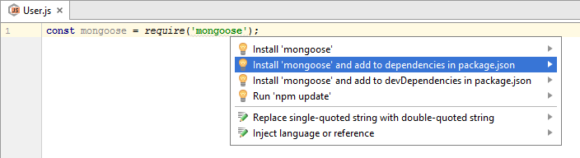

The above command “require” will look into our libraries and will try to find a module with name: “mongoose” (it’s like calling using System in C# but instead of typing it on top of the file, we just assign it as a variable, in order to use the functionality in the module). Whenever we add a new module, it is a must to add it as a **dependency** in our **package.json** file. The **IDE** is smart and can do it automatically. “**Alt + Enter**“ – it’s like calling “**Ctrl + .**” in Visual Studio.

Let’s create our user schema:

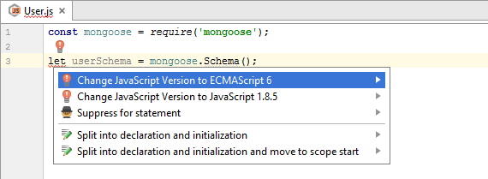

Unfortunately, when we use “let” it gets highlighted in red. This is because we have to switch our JavaScript version to ECMAScript 6. Press [Alt + Enter] to popup the helper, then click [Enter] and everything should be fine.

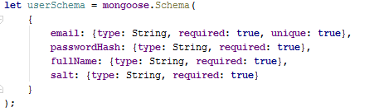

Here is what our Schema should look like. We create schema by using that mongoose module we already imported. The Schema function accepts a JavaScript [object](https://developer.mozilla.org/en-US/docs/Web/JavaScript/Data_structures). In plain words the above means: we will create a schema where every entity will have:

* email
* passwordHash
* fullName
* salt (will explain it later)

They all have the String type and they are all required. For more info on types in JavaScript read this [article](http://www.w3schools.com/js/js_datatypes.asp).

To finalize creating the **User** collection, there are two things left to do: create and export a model. A model is just a **wrapper** of our **schema**. It lets us make **queries** to the **database** directly and even **create**, **update** and **delete** **documents** from our collection. It should look like this:



Creating the model is easy: just call “mongoose.model” and pass the **model’s name** as the **first** **argument**, and then the **schema** that the model will be using. In order to export that model as a module, simply write that “module.exports” assignment. This means that every time someone requires our “User.js” file he will get the User model.

## Create Connection with MongoDB

Before we start setting up our connection with database let’s create a config.js file in our config folder (configception). There, we will store information about our **project root folder** and a **connection string**, which is needed to connect with our **database** (MongoDB).

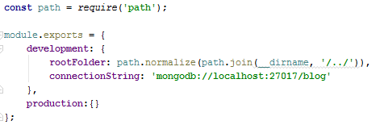

The idea behind creating a **config file** is to get our **configuration variables** from a separate place where they can **easily be changed**. Let's say that we’ll have two different configuration environments: **production** and **development**.

The two things that we will need for now are the rootFolder and the connectionString. The rootFolder can be used when we need to **declare the path** to some of the project's **dependencies**. As for the **connection string**, the mongoose module will require it so it can save the changes we made to our documents.

Let’s move onto creating the connection itself. We need to create a “**database.js**” file in our **config** folder. It should look something like this:

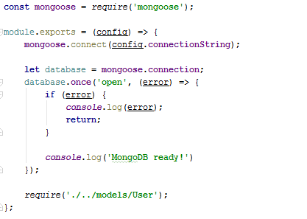

Now go back in the **app.js** file and require that **config** module. Also, make sure that the code in **database.js** is also called:

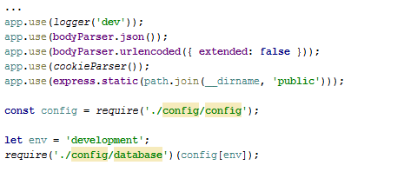

The project structure should something like this:

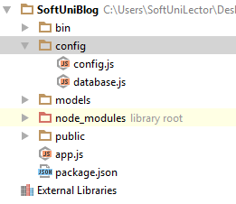

## Set Up the Security Configuration

We have our model ready. Now we need to create some **security configuration**.

First, create a folder named “**utilities**”. Inside of it, create a file named: “encryption.js“. There will be our logic for generating [salt](https://www.addedbytes.com/blog/why-you-should-always-salt-your-hashes/) and **hashing** our **password**. So, we’ll create two **functions** and make them **public** so they can be useful.

First, we will need some helper module (“crypto”). In order to make the functionality visible to the **outer world**, we will **export** an **object** which will have **two properties** which are [JavaScript](https://cdn.meme.am/cache/instances/folder522/500x/63119522.jpg) **functions**.

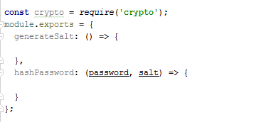

Next, let’s define the two functions (generateSalt and hashPassword) inside the module.exports statement:



Next, let’s fill in the relevant functionality for each function:

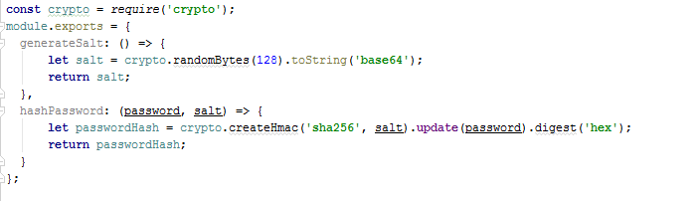

The **salt** will be generated by creating an **array** of **128 random bytes**, which are later going to be converted to their [base64](https://en.wikipedia.org/wiki/Base64) presentation. For our hashing logic, we use the [SHA256](http://www.xorbin.com/tools/sha256-hash-calculator) hashing algorithm.

Create an “**express.js**” file in the “**config**” folder. We will put some **setup logic** inside it. Simply copy the “**app.js**” file and **remove** some of the code there and add the authentication modules – it should look like this:

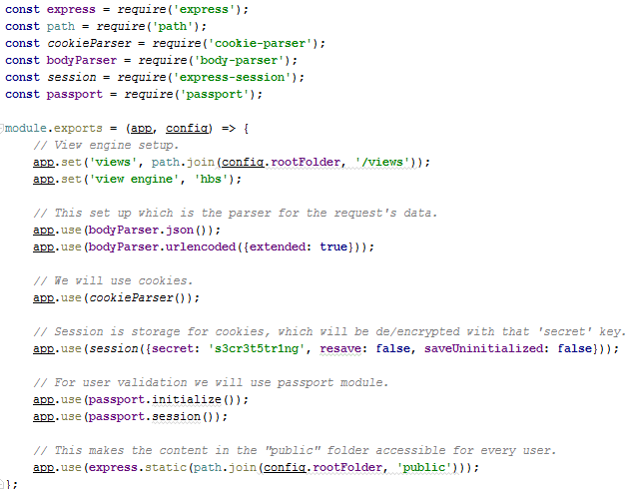

Let’s talk about the modules we are using:

* express – wraps functionality that the **Node.js** platform provides while making coding easier and faster. Look at the example with “express.static”. What it does is to take the provided file path (which is resulted by using the module below) **static**. This means that absolutely every file in that path is visible to **anybody** on our server (no-restrictions).
* path – supply utility functions for joining file paths (relative or absolute – doesn’t matter) or any tools needed around when using file paths.
* cookie-parser – cookies contain **encrypted data** about the **current user** and they are **sent on every request**. With this module, we enable **working with cookies**.
* body-parser – parses data from the request’s body and making it accessible by simply mapping that data as a object with different properties. See the [documentation](https://github.com/expressjs/body-parser).
* express-session – server-side **storage**. With that “**secret**” string, we can differentiate cookies from one another (by setting an ID to every cookie). It also keeps information about the **current user’s** **connection**. **Only for development uses**.
* passport – **security module** that uses the **session** to **save information about the user**. It requires a saving strategy (“**Facebook**”, “**Google**”, “**Local**”, etc.) and tells us which data from the user we’re going to put in the **cookie**. It binds **two functions**: logIn and logOut.

Now let’s create a “**passport.js**” file in the “**config**” folder in and choose an authentication strategy for our login:

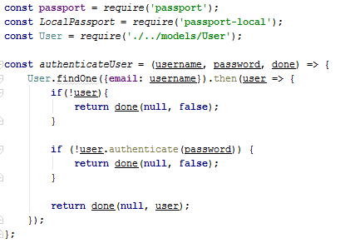

As you see, we have declared a function to authenticate a user by their **username** and **password**. This means that first, the **username** should exist in the database and second - the given **password** should be **equal** to the one in the **database** (**hashed** of course).

Additionally, our function receives a **third argument** called “**done**” – another function which will be invoked **inside** the current function.

The logic behind that is to pass any **errors** (if any have occurred) as the **first argument** and **the user** as the **second argument**. If we can’t authenticate the user, we return the errors in the first argument, and if we can, we just pass **null**. Otherwise, we return the **user**. This logic is needed to implement the Passport Login strategy. In this project, we will use “**Local Passport**” strategy. This means that the current user will be authorized only in the borders of our application (you can have a Facebook passport strategy where you will use Facebook credentials to log in).

Here we use authentication method from the **User’s** model. It’s job will be to see if the currently given password is matching the original one. Here is the logic in the User’s **schema**:

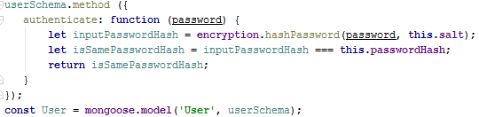

The passport module will provide us with two functions (as said above) which means that it **automatically** takes care of **login/logout**. However, the input data may be called differently than “**email**” and “**password**” (aka in our **html** form the **input fields** can be **named differently**), therefore we can pass some **configuration object**, in which we can set these names (usernameField: username). And to make that strategy complete, we should pass it to the passport module using the keyword: “use”.

Next, we will need to implement two functions for our **passport** module. They are called: serializeUser and deserializeUser. **Passport** is responsible for **distinguishing users** (as the passport in real life), so to do that, we should tell it how to **differentiate users**.

The code for this looks like this:

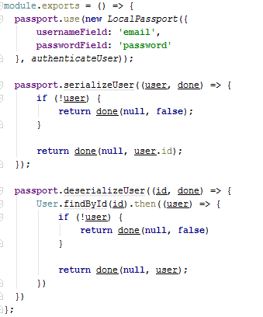

Let’s break down what it does:

* serializeUser – we give it the **user object** (user variable), and a donefunction. If we don’t have a user, we call done with **null**, and if we do, we return the user’s **id**.
* deserializeUser – we give it the **user id** (user variable), and a donefunction. If we don’t have a user, we call done with **null**, and if we do, we return the **user** as an **object**.

Since we moved a lot of our logic in the “**express.js**” module we can safely **remove** **it** from “**app.js**”. Here is how the “**app.js**” should look in the end:

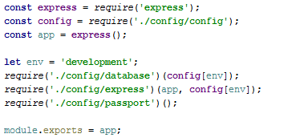

Here is how the project structure should look like **after** **the addition** of these three modules:

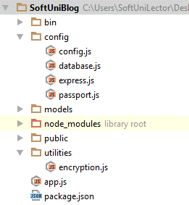

## Register User

Now that we have our **authentication** strategy and entity **model**, let’s start creating some **views** to **register** our first user!

Create a “**user**” folder in the “**views**” folder. Put a “**register.hbs**” file in it and copy the following **html**:

|  |
| --- |
| <**div class="container body-content span=8 offset=2"**>  <**div class="well"**>  <**form class="form-horizontal" method="post" action="/user/register"**>  <**fieldset**>  <**legend**>Register</**legend**>  <**div class="form-group"**>  <**label class="col-sm-4 control-label" for="inputEmail"**>Email</**label**>  <**div class="col-sm-4 "**>  <**input type="text" class="form-control" id="inputEmail" placeholder="Email" name="email" required value=**{{**email**}} >  </**div**>  </**div**>  <**div class="form-group"**>  <**label class="col-sm-4 control-label" for="inputFullName"**>Full Name</**label**>  <**div class="col-sm-4 "**>  <**input type="text" class="form-control" id="inputFullName" placeholder="Full Name" required name="fullName" value=**{{**fullName**}}>  </**div**>  </**div**>  <**div class="form-group"**>  <**label class="col-sm-4 control-label" for="inputPassword"**>Password</**label**>  <**div class="col-sm-4"**>  <**input type="password" class="form-control" id="inputPassword" placeholder="Password" required name="password"**>  </**div**>  </**div**>  <**div class="form-group"**>  <**label class="col-sm-4 control-label"**>Confirm Password</**label**>  <**div class="col-sm-4"**>  <**input type="password" class="form-control" id="inputPassword" placeholder="Confirm Password" required name="repeatedPassword"**>  </**div**>  </**div**>  <**div class="form-group"**>  <**div class="col-sm-4 col-sm-offset-4"**>  <**button type="reset" class="btn btn-default"**>Cancel</**button**>  <**button type="submit" class="btn btn-primary"**>Submit</**button**>  </**div**>  </**div**>  </**fieldset**>  </**form**>  </**div**> </**div**> |

Now, after we have our user registration view, let’s create a **controller** to render it.

Let’s create a folder named “**controllers**”. Inside it, create a file called “**user.js**”. We will put everything all the logic, which will manipulate our User model there. **Add a function**, which will render the **html** passed above:

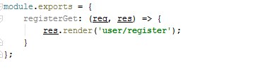

Our function in the controller will receive the request and response as parameters.

What we need now is to define routes (routes will say which controller when to be called). The logic of routes is simple and lay on [REST](http://www.andrewhavens.com/posts/20/beginners-guide-to-creating-a-rest-api/) API definition. Let’s **delete the routes folder** we have and create a “**routes.js**” file in the “**config**” folder where we can handle all requests:

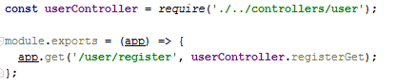

Now, require it in our **app.js** file:

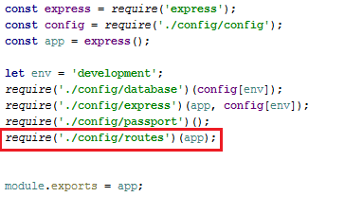

If everything is ok and we **run the server**, when we go on localhost:3000/user/register, the following should be displayed:

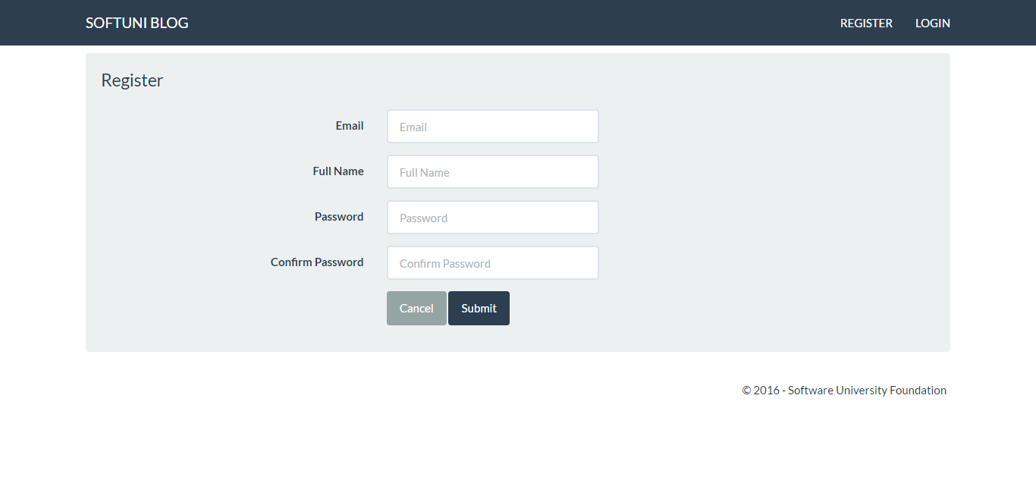

Our form got displayed (using a **GET** request)!

Let’s dive deeper in “**user/register.hbs**”. If we look at the <form> tag, we can see that the form has **two attributes: (key 🡺 value)** pairs:

* **method 🡺 post**
* **action 🡺 /user/register**

This simply means that whenever this form is submitted (aka the button of type “submit” is clicked). It will create a POST request towards the URL described above:



This means that we need to **create a new route** with **same URL**, but **different HTTP method (**POST**)**:

First, add the route to the in “**routes.js**” file:  
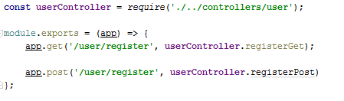

Second create a new action in the User’s controller. That action should do the following:



We need to parse the input data. We can find it in the **request’s** **body**. You can access concrete arguments from it by passing the name of the input field (taken from the html). If we look at “**user/register.hbs**”, we can see that every input field has a name attribute (name="email" and so on):



So, if we want to take the “**email**” value, we can do it with: “registerArgs.email”. For more clarity look at the pictures below.

Second, we need to write our **validation logic**, which needs to answer **two questions**:

* Is the given email **already registered**?
* Do **both passwords match**?

If the answer to both of those questions is “**yes**”, only then can we register the user.

Before we can answer the questions, we need to figure out how we can search the models for data. Luckily, **Mongoose** gives us this functionality. All we need to do is require() the **User** model and then just use Mongoose’s built-in methods:



At this point, our user.js controller should look like this:

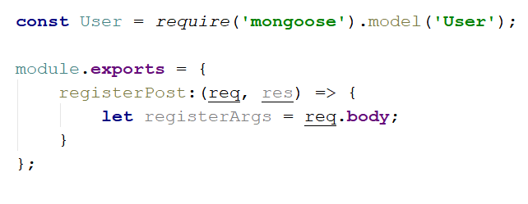

Now, back to validation. Let’s answer the validation questions. To do that, we need to **connect to our database** and **check** if there is **already a user with that email**. This can be done by using the Mongoose findOne() function. This command accepts an **object**, which we can use as a **filter**:



However here is something very important: this function is **asynchronous** (like most query functions) and it will **not** directly return the user. This means that we **cannot** do something like this:



Instead we need to use **promises**, which are essentially just **chained functions**. You can use a promise with the keyword then().

For example, if we wanted to **print** a **user** with a specific **email** like in the code above, we would write the following:



Now, after we’ve found the user, let’s **validate** if the **user exists** and if the **passwords match**:

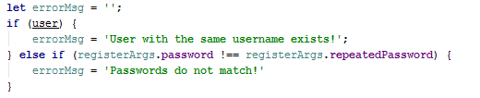

For every error case, we will create a **string** variable in which we’ll save the error message. Note that **JavaScript** is **weird** when speaking about **truthy** and **falsy** values. Read this [article](http://james.padolsey.com/javascript/truthy-falsey/) for further clarity.

Now, let’s analyze what the logic in the above screenshot does:

If the user variable returns anything, that’s **bad**, because it means there’s **already a user with that email** in the **database**. If there weren’t, it would have returned **null**.

We can convert the **user** variable to true/false by just putting it in an ifstatement. An undefined value would be converted into false and an existing user, (which isn’t undefined) into true.

After we have our validations, we should check for any **errors**:

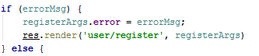

If any errors occurred, we will simply **reload** **the page**. The key thing here is that we will reload it **with the previous values** (so that the user doesn’t have their form cleared), and with the **error message**. The error message will be **displayed** in the layout (“**layout.hbs**”).

On the other hand, if we **didn’t have any errors**,we should insert a **new entity** in the database and **log** the user **in**:

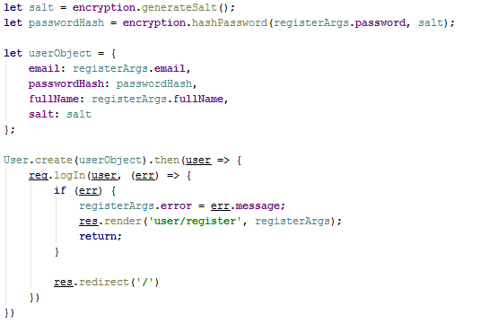

*Do not forget to require the “User” model and the “encryption” utility module!*

One last thing before we move on to the **Login** form – go to the “**express.js**” file and add the following:

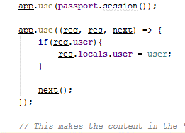

We have just declared a [middleware](http://expressjs.com/en/guide/using-middleware.html), which will simply make our current user visible for both the views and the controllers.

## Login Form

We will create our login functionallity in the same fashion we created the register one. In the previous step we did the following: register form **view** -> **controller** -> **route** -> **controller**.

Create “login.hbs” in “views/user” folders:

|  |
| --- |
| <**div class="container body-content span=8 offset=2"**>  <**div class="well"**>  <**form class="form-horizontal" method="post" action="/user/login"**>  <**fieldset**>  <**legend**>Login</**legend**>  <**div class="form-group"**>  <**label class="col-sm-4 control-label"**>Email</**label**>  <**div class="col-sm-4 "**>  <**input type="text" class="form-control" id="inputEmail" placeholder="Email" name="email"**>  </**div**>  </**div**>  <**div class="form-group"**>  <**label class="col-sm-4 control-label"**>Password</**label**>  <**div class="col-sm-4"**>  <**input type="password" class="form-control" id="inputPassword" placeholder="Password" name="password"**>  </**div**>  </**div**>  <**div class="form-group"**>  <**div class="col-sm-4 col-sm-offset-4"**>  <**a class="btn btn-default" href="/"**>Cancel</**a**>  <**button type="submit" class="btn btn-primary"**>Login</**button**>  </**div**>  </**div**>  </**fieldset**>  </**form**>  </**div**> </**div**> |

Then add the **action** in the **user controller**:

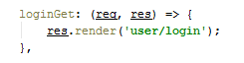

After that, extend the “**routes.js**” file with our **login** **get** action:



It’s time to go back to the **user** **controller** and create the **login logic**. Just like with registration, we need to answer a couple **validation questions** before we let the user log in:

* Does the user exist?
* If so, does the **password** (when hashed) they gave us match the **hashed** **password** given in the input?

The easiest way to do that is to give every **User** a **validation function**. This is the easiest way because the users have all the needed information (**salt** and **passwordHash**). Go to the **User.js** in “**models**” folder and add this block of code:

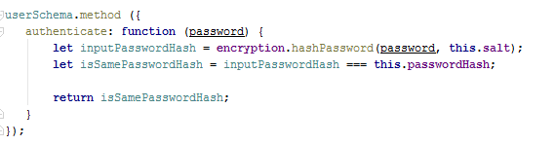

Make sure that this **method** appears **before** the one, which creates the User’s **model** (“mongoose.model”)**.**

Again on the **controller**. Write a search query (aka User.findOne) and **validate** user’s input:

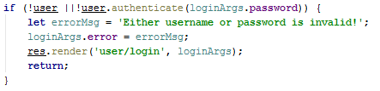

So, we have some **validation** on the input, what left is to actually **log** the **user in**. You may use the **same** logic **as** we used in the **registration** section.

## Logout

Logging out is very simple. Let’s add it in the **user controller**:

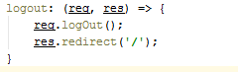

Add the **logout route**. Here is how “**routes.js**” should look at this point:

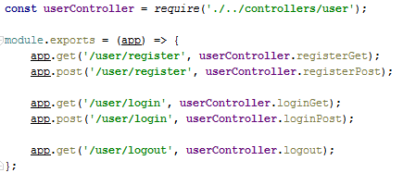

# Creating Articles

## Start MongoDB (Only if you are here from the start)

Before going ham on MongoDB, let’s clarify some things. MongoDB is a **NoSQL** database. But what is database? A **Database** is just some **storage** for information. For now, we can assume that a database is just a bunch of **tables** in which we **save information** (SQL). Here is how our **User table** looks like from previous steps:

We have a couple of **tables**, each of them have some **columns** which give us the opportunity to **store** **data in them**. This is what a typical SQL database looks like:



**MongoDB** uses a slightly different approach. Instead of saving the data into a **table-columns** format, it parses **every object** to a **JSON** **string** and saves it. That’s all! Here is an example of a **user** **object** saved in **MongoDB**:

**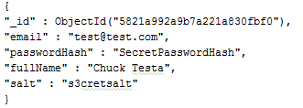**

One more thing: concrete **objects** are named **documents**, and a list of **grouped** **documents** is called a **collection** (contrary to SQL, where one object consists of a **row** of **several columns**, which is inside a **table**).

Enough talk, let’s do some action:

1. **Open** a **MongoDB** **connection** – open **Command Prompt** in the **directory**, where mongo is installed (Example: “C:\Program Files\MongoDB\Server\3.2\bin”) and type **“**mongod --dbpath "D:\test\example"”. What this will do is: **create a server** (locally) on the default **port** (**27017**) and will wait for any command.
2. **Connect** to the newly-created server: depends on whether you are using **console** or **GUI client**
   * For a **console** **client** simply run the “**mongo**” command. But in **different** window.
   * For **RoboMongo**, just **start the application** and **connect** to the **Mongo server**.

Now you can communicate with the database and execute [commands](https://docs.mongodb.com/v3.2/reference/command/).

You can create a database named “**blog**”. Check out the “[Create database](#_Create_a_Database)” step for steps on how to do that.

Summary: We now know the simple definition of a database. We saw different ideas for implementing a database. Also, we learned how to start a MongoDB server from which we can create and manipulate different databases.

Here is how your connection **might** look like:

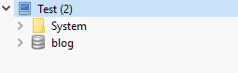

## Open/Create project

We have our database ready. Let’s go ahead and load the skeleton. Click open and find the downloaded and unzipped skeleton project:

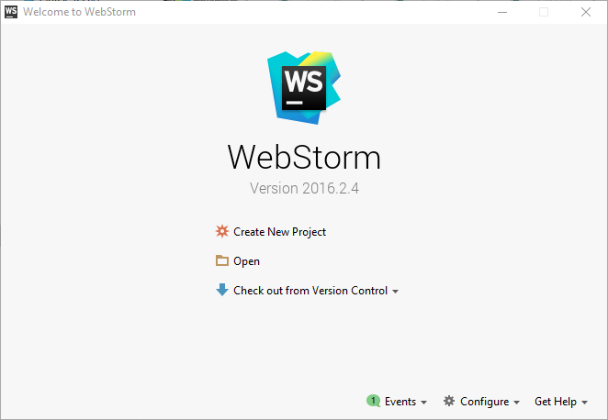

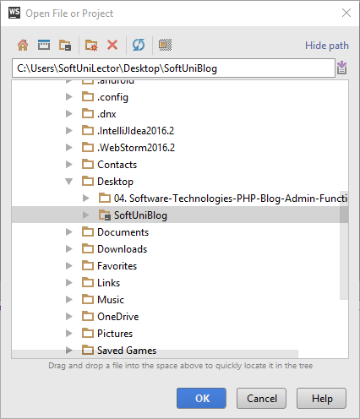

Note that the skeleton project has also **one more** controller named “**home**” and one more folder in “**views**”, also named “**home**”. Don’t worry if you don’t have them at the moment, we will talk about them later. Here is how the project structure should look like:

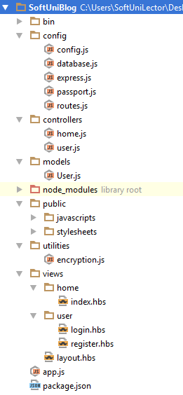

This is our **Node.js** project. In the previous steps, we saw how we got here. Now let’s talk a little bit about **Node**:

**Node.JS** is a **platform** written in **JavaScript**, which provides **back-end** functionality. This gives us a lot of flexibility because our **front-end** (HTML, using [jQuery](https://jquery.com/), [Ajax](http://www.w3schools.com/xml/ajax_intro.asp) etc.) **also** uses **JavaScript**. This makes mutual **communication** easier. It is fast because it uses C++ behind the scenes and also, because it’s capable of making **asynchronous calls**. It uses the event loop [system](https://www.tutorialspoint.com/nodejs/nodejs_event_loop.htm).

Summary: we have downloaded the project and we are ready for further action!

## Create the Article Model

It is time to design our main entity – the **Article**. It will have the following properties:

* title
* content
* author
* date

The interesting property here is the **author** property, because it is **already** a **model** in our database. Imagine that if every time we created an **article**, we **bound** that author’s **information** to the article. What happens when one **author** creates **50** **articles**? Would we store the same **author name** and **other** **properties** for every single one? Wouldn’t that be a huge waste of **memory**? Yes, so how can we resolve that problem?

The answer is what’s called a **reference** key (something **unique** for the author – like an **ID** or a **name**). When our author has an **ID**, instead of binding all the information to the article, we just **save** that author **ID** in the article.

But how do we retrieve information about a specific **article’s author**, you ask. Well, we can always just **look them up** in the database, using the **ID**, which we saved inside the article. This is called (database) **relations**. One author has zero or many articles. We will cover on that more in the next chapter.

Let’s create our model in the **Mongoose** way. **In** our “**models**” **folder** **create** a **file** named “**Article**.**js**”:

1. **Define** article **schema**:  
   ****
2. **Declare** **properties** with their types and any other **constraints** (such as **default** values, is current property **unique**, is it **required** and so on…):  
   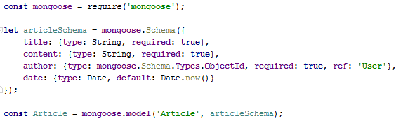

Look at how we created the **user schema** as well (if you skipped the first 3 chapters).

**Two** key **things** to notice:

* The **author** has the “mongoose.Schema.Types.ObjectId” **type**. That ObjectId is the type of the **unique** **identifier** that our database puts on every document in order to differentiate between two documents. This is done **when** you **initially** **save** a document (aka **when** you **create** an article – the database will generate an “**id**” **property** – it may simply be just a string with **unique** content).
* The “**ref**” property, which is telling **Mongoose** that this “**id**” will **reference** the “**User**” collection.

After we have defined our schema with all of it’s relations and constraints we will **wrap** it in a model. **Model** gives us the functionallity to perform **CRUD** operations. This means that if I **create** an **article** which has the same structure like the article’s schema (aka object **with** **title**, **content** etc.) by using the Model wrapper we can **save** it **to** the **database**. See this [guide](http://mongoosejs.com/docs/guide.html) for more explanation.

Almost done: let’s **export** our model, so it can be visible for the outer world:



One last thing: we need to add a reference to the **Article model** in our **database.js** file, so our database can know articles exist and can use them:



**Summary**: we now know how to create a user schema, wrap it in a model and define a relation with another model.

## Create Author – Article Relationship

Our **program** is like our real world – it is **based** on **connections** and interactions between it’s elements. We have a **user** which has **zero** or **more** **articles**. This relation is called **one** to **many**. We might want the **articles** to have **tags**. Many articles with many tags. Again relation – this one is called **many** to **many**. Our articles may have categories. **One** **article** – **one** **category**, from this side it looks like a **one** to **one** relation. Well, this is true **but** keep in mind that **one** **category** may have **many** **articles**. Here is the conclusion: relations can be: **One to One**, **One to Many**, **Many to Many**. There is one more called **One to Few**.

Let’s go back to the **author** - **article** relation. One article will have one author. We defined it with property in the article model. In order to complete the relation we have to change current user’s schema. In database world this is called **Migration**. Let’s do the migration in the **user’s schema**:

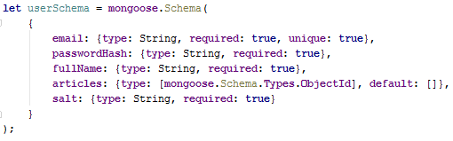

Just **add** the **property** articles, which will have the type **ObjectId** **array** type, and a **default** value, which is an empty array. This is our **migration**.

Summary: a database **relation** defines **connection** between two entities. The **relation** type depends on the point of **view**. In MongoDB **migrations** are as free as **changing** the **model**.

## Apply Database Migrations

In the **MongoDB** world, where we don’t have tables and columns, relations between models are **more loose**. The whole [responsibility](https://media.tenor.co/images/4c3b395bb7e3b40b780ac97f287b6ab3/raw) of handling a migration is given to the programmer **(for better or for worse)**. There are some [frameworks](https://github.com/emirotin/mongodb-migrations) that might help us with that, but for the scope of our project it would be too overkill to use one.

Let’s continue with our logic. In order to keep our data up to date we have to find all users who do not have an ”**articles**” property and set the default value of it, so we don’t get any errors down the road when we actually start creating articles. This simply means that every change that we made to the schema will affect every next document inserted and will not make any update on existing documents.

This migration problem has two solutions: either delete all the old data and start over or run an update query on the not-updated entities. This can be done with the following command.

* If we want to use the console, just execute this statement:

|  |
| --- |
| **db.getCollection('users').update({articles: {$exists: false}}, { $set: {articles: []}}, {multi: true})** |

* If we want to use RoboMongo, we need to right click the **blog** database and **click Open Shell**, after which we can **paste** the command from above and click **F5** to execute it:  
  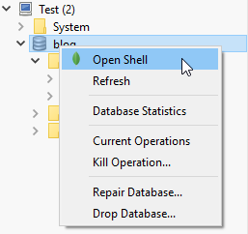

Let’s look closer on this query:

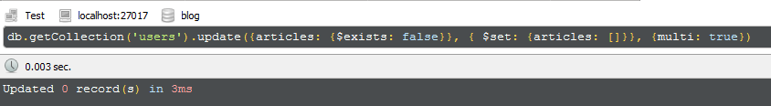

* db.getCollection('users') – find all users.
* update() – update the first match found (by default)
* {articles: {$exists: false}} – for every user where “articles” is not existing property.
* {$set: {articles: []}} – sets “articles” value to empty array.
* {multi: true} – update all matches, not just the first one.

[Source](http://mongoosejs.com/docs/api.html#model_Model.update).

**Summary**: When having a **migration** we are the ones to **update**/delete the already **existing** data. Updating can be done with the “**update**” command and we can **pass** some **filter** **arguments** to it.

## Create the Article Controller

The next part will be creating the **article controller** where we will put all the logic connected directly with the **Article** model. Create an “**article.js**” file in the “**controllers**” folder. As a starter, we want to create a method which will render the form for creating an article. The controller might look like this:

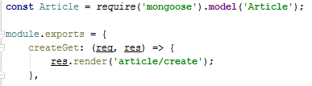

Note that we can require a mongoose **model** through the mongoose module just by passing the model’s **name**. Important thing about this way is that the code, initializing the Article model must be compiled before we try to access the model.

With the above code are in need to create a view which will render the form for creating article.

## Templating Article Form

In the beginning of the project creation we said that we will use the **Handlebars** view engine. So, this time, instead of copying the html and directly moving forward let’s see how **templating** is done. As an example, we’ll take on **layout.hbs:**

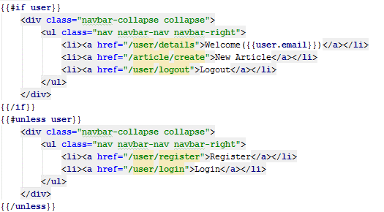

We can see that there is a lot of html but also there are multiple blocks of code which are not. These parts are for the **view engine**. Let’s explain what it does to the code.

With double curly brackets “**{{**”, we say that the next part will not be html but a **command** for our **view engine**. This scope for the command ends with next **closing curly brackets** – “**}}**”. In the current example, we can see that we have an **if** statement (#if). If the **variable** passed to the “if” is **truthy**, all the html until the **{{/if}}** will be displayed.

Okay, but what if the variable is **falsy** and we want to display something different? We will use “**unless**” in the same way that we used “if”.

In the end, the result will be: if there is any user logged in, display the first blog html (with “Welcome”, “Logout” etc.), else display the other blog html (“**Register**”, “**Login**” etc.)

But how does the view know about the current user? Look at “**express.js**” – there is a middleware that binds user in way that allows to be visible to the view (if you don’t have that middleware – write it somewhere after **passport.session()**):

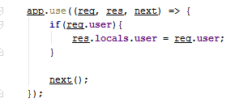

Another **thing** to mention: look at the first **<a> tag** – there is a block “{{**user.email**}}”. This simply means that we can not only use “**user**” as a boolean but to actually **take** **data** from it! There are more commands to use (like “each”), but we’ll cover that later. For now, let’s go back to the article. We need a view which will display an **html** **form**. In this form, **data** (title, content etc.) will be **inserted** and we’ll have to take that data **into** our logic (for example, a **controller**). Create a “**views/article/create.hbs**” file:

|  |
| --- |
| <**div class="container body-content span=8 offset=2"**>  <**div class="well"**>  <**form class="form-horizontal" method="POST" action="/article/create"**>  <**fieldset**>  <**legend**>New Article</**legend**>   <**div class="form-group"**>  <**label class="col-sm-4 control-label" for="articleTitle"**>Article Title</**label**>  <**div class="col-sm-4 "**>  <**input type="text" class="form-control" id="articleTitle" placeholder="Article Title" name="title" required** >  </**div**>  </**div**>  <**div class="form-group"**>  <**label class="col-sm-4 control-label" for="articleContent"**>Content</**label**>  <**div class="col-sm-6"**>  <**textarea class="form-control" id="articleContent" rows="5" name="content" required**></**textarea**>  </**div**>  </**div**>   <**div class="form-group"**>  <**div class="col-sm-4 col-sm-offset-4"**>   <**button type="reset" class="btn btn-default"**>Cancel</**button**>   <**button type="submit" class="btn btn-primary"**>Submit</**button**>  </**div**>  </**div**>  </**fieldset**>  </**form**>  </**div**> </**div**> |

Our **form** html tag contains two important attributes: **method** – which defines what the HTTP [method](https://www.tutorialspoint.com/http/http_methods.htm) of the request will be, and **action** – the actual link where we want the data to go. So, wherever this form is submitted the request will go where the **action** attribute points.

**Summary**: The **view engine** helps us **put** **logic** in our views and also helps us **display** even **more** information. The best thing here is that that logic can be put **directly** **into** our **html** code. ☺

## Finalize Article Creation

After we have our form displayed, it’s time to parse its data and complete our article creation. Go back to “**controllers/article.js**” and create another function to handle that logic:

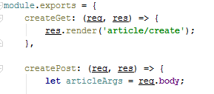

This is how the article controller should look for now. We have our article data parsed so start making some **validations**:

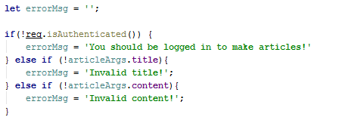

req.isAuthenticated() comes from the passport module and it checks if there is currently a logged in user. This validation is optional for now. Other checks validate if the **title/content** is **empty/undefined/null**. If they are, an error message is created.

After all validations, there are two things we can do: either **inform the user** if an error occurred, or **create an article article** and **store** it in the **database**:

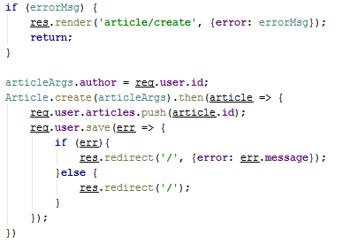

Here’s how the control flow goes:

* If there are **any** **errors**, we will:
  + **Re-render** the same page, but this time, we’ll pass an object **with** an “**error**” property, whose textwill be displayed in the “**layout.hbs**”.
* If there **isn’t any error**, we will:
  + **Assign** the **author’s** **id** to the **article** object
  + **Save** the article to the database
  + Attach an “**id**” to the **article**, which we will **add** to the **author’s** **articles** later.

Here is our **redirect**. We just say **where** to redirect (in our case will be just the home page – ‘’**/**”) and pass any additional info (object) to the view engine (if needed).

Now we need to **add** the routes to our “**routes.js**” file. First require the articleController:

C:\Users\Kalin\AppData\Local\Microsoft\Windows\INetCache\Content.Word\webstorm64_2017-07-27_13-01-54.png

And **attach** **functions** to the POST and GET methods on the **“/article/create**” URL:



***If you are using the skeleton skip the following step****:*

**Create** a **folder** named “**home**” **in** the “**views**” folder. Then create an empty “**index.hbs**” file. Go to “controllers” folder and add new controller named – “**home.js**”. Inside of it just simply type:

|  |
| --- |
| module.exports = {  index: (req, res) => {  res.render(**'home/index'**);   } }; |

And don’t forget to **require** the **Article.js** in the **database.js** :



Then, add the **home controller** into the “**routes.js**” and the “**home**” routing:

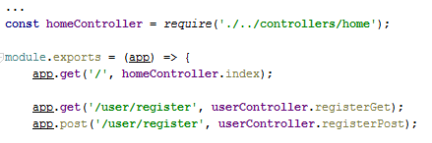

If you had problems with this setup (or any other) feel free to look from the skeleton. ☺

Summary: We have completed our logic for creating articles. We have performed **validations** and based on them we can **inform** our **user** for any errors. After **saving** the **article** in the database we **update** our user’s **articles**.

# Read Articles

In this part, we will focus on manipulating the article entity.

## List Articles

What we will try to do now is to display **6** articles with **information** about every one of them. We want to do it on our home, so let’s go the “home/index.hbs” view and type the following:

|  |
| --- |
| <**div class="container body-content"**>  <**div class="row"**>  {{#**each articles**}}  <**div class="col-md-6"**>  <**article**>  <**header**>  <**h2**>{{**this**.**title**}}</**h2**>  </**header**>   <**p**>{{**this**.**content**}}  </**p**>   <**small class="author"**>  {{**this**.**author**.**fullName**}}  </**small**>   <**footer**>  <**div class="pull-right"**>  <**a class="btn btn-default btn-xs" href="/article/details/**{{**this**.**id**}}**"**>Read more **&raquo;**</**a**>  </**div**>  </**footer**>  </**article**>  </**div**>  {{/**each**}}  </**div**> </**div**> |

Here, we use Handlebars’ full strength. We are using an “**each**” construction (which works the same way as foreach in some languages).

We go through **every article** which was passed to us. For every single one we will display:

* its **title** (using **this** means that we are iterating over the **current** **article**)
* its **content**
* its **author**

The interesting part here is that we pass this statement: “**this.author.fullName**”. Remember when we created the Article **model**? The “**author**” property **was** of type “**ObjectId**”, right? Here comes the cruicial point in getting the whole information (from our relation). Let’s see how we will get that information from the “**home**” controller:

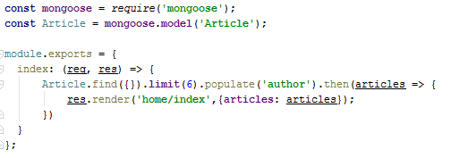

What this will do is:

* Retrieve all the articles
* Get **only the first** **6** of them
* **Populate** their “**author**” property (put **all** **of** the author’s information there instead of just their **ID**)
* Send them to the “home/index” view.

Populate example: If we have an **article** with an “**author**” **property** = “**a3fvce4GtT**” (which is the author’s ID) and we say that we want to populate that property, **MongoDB** will search in the **User** model for a user with the **same ID** and simply attach **all the information** it has for that user.

Also, notice the **link** for the “**Read more**”: it is “**article/details/*this.id***”. This means that every article we want to display will have a unique **route** (URL), based on the **article’s id**. This is how our **controller** can get information about the article we want to see. We will go deeper in the next chapter.

Here is how the article should appear in our homepage:

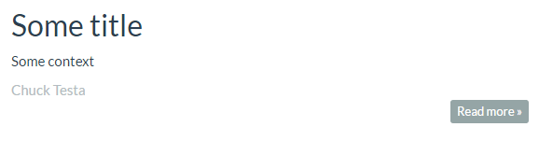

Summary: We now know how we can **iterate** over an **object** in our **view** engine. Also, we saw the basics of “**populating**” a **relation** property.

## Details Articles

Have you noticed the “**Read more**” button? Let’s implement it. We want to display **more detailed information** about the specific article when we click on it.

Again, our first step is to **generate the view**. This means that we have to create a file named “**details.hbs**” in our “**views/article**” folder:

|  |
| --- |
| <**div class="container body-content"**>  <**div class="row"**>  <**div class="col-md-12"**>  <**article**>  <**header**>  <**h2**>{{**title**}}</**h2**>  </**header**>   <**p**>  {{**content**}}  </**p**>   <**small class="author"**>  {{**author**.**fullName**}}  </**small**>   <**footer**>  <**div class="pull-right"**>  <**a class="btn btn-default btn-xs" href="/"**>Back **&raquo;**</**a**>  </**div**>  </**footer**>  </**article**>  </**div**>  </**div**> </**div**> |

We have the view, now let’s use it in our controller:

Whenever we want to so see the **details** of an article, it’s only logical to **tell the server** which article we want to see. This information will be sent through the **URL**. In the URL, we will pass the **article’s “id”** (we already did in the “**index.hbs**”). Once we get that “**id**” on the server side, we can **find** the specific **article** by its **id** and then **pass it** on to the **view engine**.

How do we get the information from the link? We will use req.params. But first let’s look how our routing will look in “**routes.js**”**:**

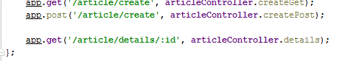

Just add the “**/article/details/:id**” part. This means that in the end of our link, we are expecting a **parameter** named “**id**”. Later on when using req.params, we can **access** that parameter by just **getting** its name as a property of the req.params object.

So, if we want to get a parameter with the name “**id**”, we will write req.params.id. This is how we get **parameters** from our **URL** (*note: req.params is different from req.body*).

Let’s implement the details page in **article** **controller** (**article.js**):

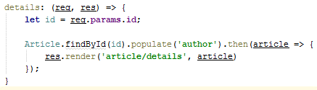

Now everything should be implemented and we should be able to get an article’s details when we press the **read more** button next to an article!

**Summary**: We saw how to **display** more **detailed** **information** about an **article**. We **passed** the needed **parameters** in our **URL**, which we can easily work with from the **server’s side**. This way we can get **information** about an **article** by just giving the server its **id**.

Congratulations, you’ve just implemented a basic blog system, using Note.JS as a **server**, ExpressJS as a router, Mongoose as an **ORM**, MongoDB as a **database** and Handlebars as a **view engine**! Feel free to implement any additional functionality using your newfound knowledge (try to implement profile view for every user). Happy coding! ☺